Matthew Garcia Nieves
Enhancement Two: Algorithms and Data Structures
10/15/2026
Artifact Description
The artifact I selected is my ABCU Advising Assistance Program from CS 300: Data Structures and Algorithms. I created the program in August 2025 using C++. It loads course information from a CSV file into a hash table and allows the user to print a course list or search for a course and view its prerequisites.
Why I Selected It and What I Improved
I selected this project because it was one of my better examples of working with data structures, but the original program did not do much with the prerequisite information besides displaying it. This gave me an opportunity to add more algorithmic logic while keeping the original purpose of the program.
I added three main improvements. First, the program now checks each prerequisite against the hash table when course data is loaded. If a prerequisite does not exist, the file is rejected instead of allowing invalid data into the program.
Second, I added depth-first search (DFS) to detect circular prerequisite relationships. I used an unordered_map to keep track of each course while the algorithm runs. A value of zero means the course has not been visited, one means it is currently being checked, and two means it has already been completed. If the algorithm reaches a course marked as one again, it means there is a circular relationship, and the course data is rejected. When a course is marked as two, the program knows it has already been checked and does not need to go through its prerequisites again.
Finally, I added a recommended course order using another DFS function. This is a form of topological ordering because the program visits each course's prerequisites before adding the course itself to the final list. I used an unordered_map to track which courses had already been visited and a vector to store the recommended order. This makes sure prerequisites appear before the courses that depend on them, rather than simply sorting everything alphabetically. The DFS operations have an average time complexity of O(V + E), where V represents courses and E represents prerequisite relationships. The program also continues to use an unordered_map as its hash table for storing courses, which provides an average lookup time of O(1). Hash table lookups can take longer if collisions occur, but they are generally efficient for finding individual courses.
Course Outcomes
This enhancement mainly supports Course Outcome 3. I used a hash table and depth-first search to solve a problem involving relationships between courses and had to consider why the original alphabetical sort was not enough. An alphabetical list works for displaying courses, but it does not determine which courses need to come before others.
The enhancement also supports Outcome 4 because I used additional programming techniques to make an existing application more useful and reliable. I do not have any changes to my original outcome plan. Outcomes 3 and 4 still fit this artifact, with Outcome 3 being the main focus.
Reflection on the Enhancement
The biggest thing I learned from this enhancement was how the same data can be used differently depending on the problem being solved. The original program already stored prerequisite information, but I was mostly treating it as information to display. For this enhancement, I had to treat the prerequisites as relationships between courses. This gave me a better understanding of why an algorithm like depth-first search is useful.
I completed the enhancement in smaller pieces and tested each one before continuing. I first tested the original eight-course file and then created separate test files for a missing prerequisite and a circular prerequisite. The missing-prerequisite test used a nonexistent CSCI999 prerequisite, which the program correctly detected and rejected. I also created a circular relationship between CSCI200 and CSCI300, and the DFS correctly detected and rejected it.
After adding the recommended course order, I confirmed that prerequisites appeared before the courses that required them. I also retested the original functionality. CSCI400 correctly displayed CSCI301 and CSCI350 as prerequisites, CSCI999 returned that the course was not found, and all eight courses still displayed correctly in the original course list. I also tested the new option without loading data first and confirmed that the program handled it without crashing. I documented the main tests with the five screenshots below.
One challenge was making sure that adding the new algorithms did not break the original program. Testing successful inputs along with missing, circular, and invalid data showed me why testing only the normal input is not enough. Overall, this enhancement gave me a better understanding of how hash tables and depth-first search can work together to solve different parts of the same problem.
Testing Evidence
Missing Prerequisite Test
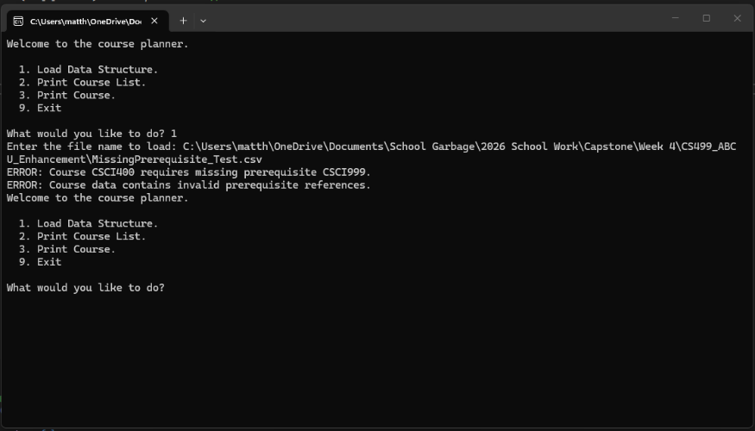
The program correctly detected that CSCI400 referenced the missing prerequisite CSCI999 and rejected the invalid course data.

Circular Prerequisite Test
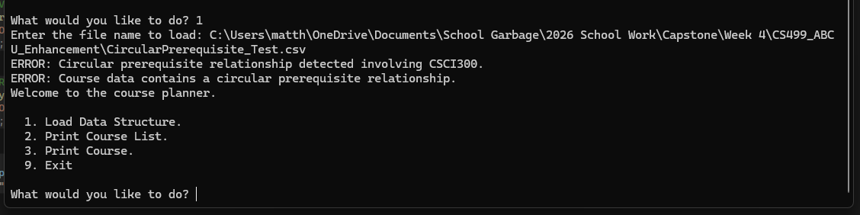
The DFS algorithm correctly detected a circular prerequisite relationship involving CSCI300 and rejected the invalid course data.
Recommended Course Order Test
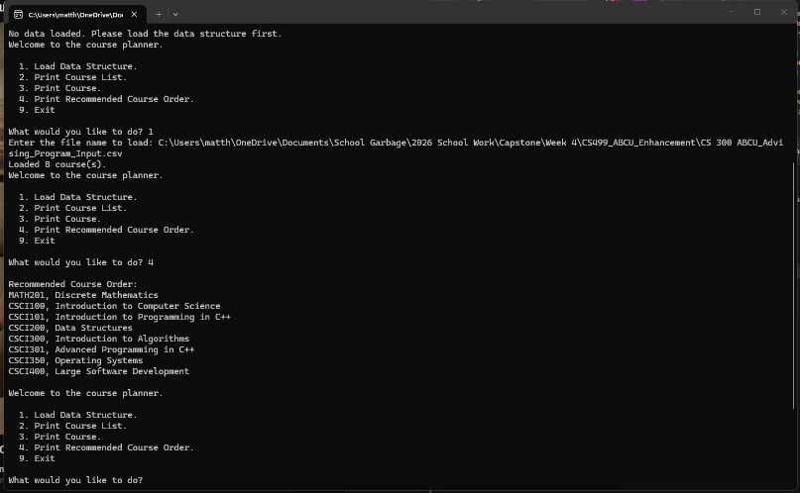
The program successfully generated a recommended course order with prerequisites appearing before the courses that depend on them.
Course Search Test
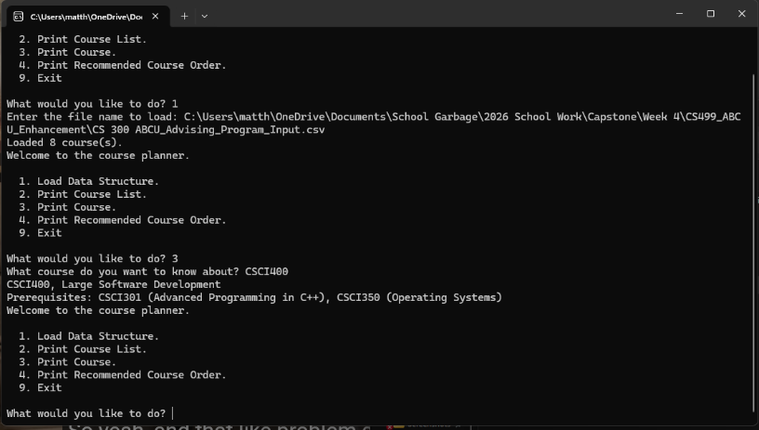
The original course search still works after the enhancements, correctly displaying CSCI301 and CSCI350 as prerequisites for CSCI400.
Course List Test
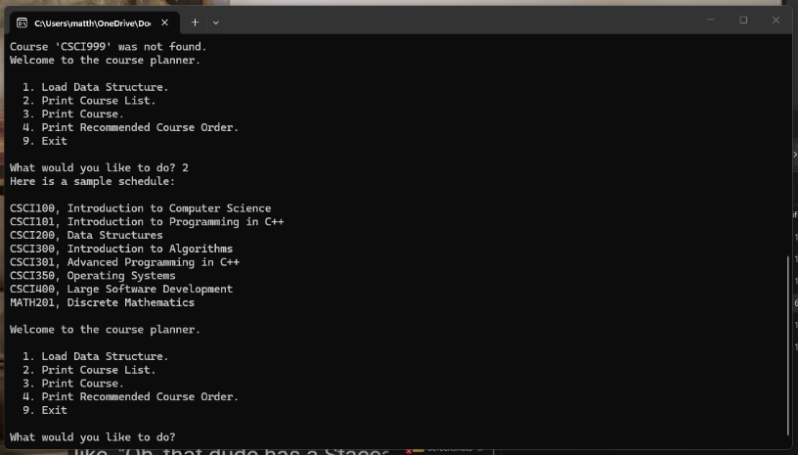
The original course list still works after the enhancements, correctly displaying all eight courses in alphanumeric order.

